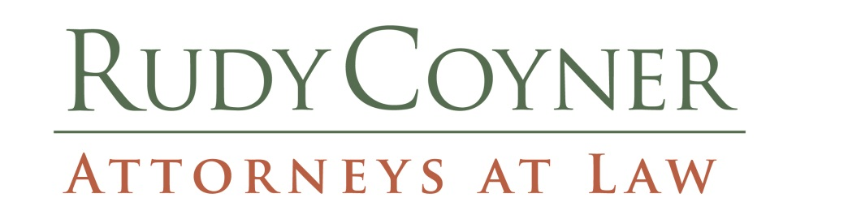
OLIVER RUDY LAW BUILDING
9910 WAGNERS WAY
P.O. BOX 58
CHESTERFIELD, VA 23832

CARRIE E. COYNER Email: ccoyner@rudycoyner.com
Telephone (804) 748-3600
OLIVER RUDY (1937-2007) Fascimile (804) 748-4671

Rudy, Coyner & Associates, PLLC (the "Company") intends to help provide a safe and drug-free work environment for our clients and our employees. With this goal in mind and because of the serious drug abuse problem in today's workplace, we are establishing the following policy for existing and future employees of the Company

The Company explicitly prohibits:
- The use, possession, solicitation for, or sale of narcotics or other illegal drugs, alcohol, or prescription medication without a prescription on Company or customer premises or while performing an assignment.
- Being impaired or under the influence of legal or illegal drugs or alcohol away from the Company or customer premises, if such impairment or influence adversely affects the employee's work performance, the safety of the employee or of others, or puts at risk the Company's reputation.
- Possession, use, solicitation for, or sale of legal or illegal drugs or alcohol away from the Company or customer premises, if such activity or involvement adversely affects the employee's work performance, the safety of the employee or of others, or puts at risk the Company's reputation.
- The presence of any detectable amount of prohibited substances in the employee's system while at work, while on the premises of the company or its customers, or while on company business. "Prohibited substances" include illegal drugs, alcohol, or prescription drugs not taken in accordance with a prescription given to the employee.

The Company may conduct drug and/or alcohol testing under any of the following circumstances:
- RANDOM TESTING: Employees may be selected at random for drug and/or alcohol testing at any interval determined by the Company.
- FOR-CAUSE TESTING: The Company may ask an employee to submit to a drug and/or alcohol test at any time it feels that the employee may be under the influence of drugs or alcohol, including, but not limited to, the following circumstances: evidence of drugs or alcohol on or about the employee's person or in the employee's vicinity, unusual conduct on the employee's part that suggests impairment or influence of drugs or alcohol, negative performance patterns, or excessive and unexplained absenteeism or tardiness.
- POST-ACCIDENT TESTING: Any employee involved in an on-the-job accident or injury under circumstances that suggest possible use or influence of drugs or alcohol in the accident or injury event may be asked to submit to a drug and/or alcohol test. "Involved in an on-the-job accident or injury" means not only the one who was or could have been injured, but also any employee who potentially contributed to the accident or injury event in any way.

If an employee is tested for drugs or alcohol outside of the employment context and the results indicate a violation of this policy, or if an employee refuses a request to submit to testing under this policy, the employee may be subject to appropriate disciplinary action, up to and possibly including discharge from employment.

Seen and Agreed:

___________________________________
Signature
Print Name: _________________________

